Overview of Project

The purpose of this project was to refactor our edit our solution code from Module 2. The objective was to edit this code to loop through all the stock data and produce the same results from the module and determine if editing the code was faster.

Results

After editing the code that was worked on in Module 2. I determined that the refactored code ran quicker than the solution code. Though both codes produced the same results, the refactored returned the results quicker. An example of this is shown below. This photo is a copy of the refactored code that I believe has helped speed the process up compared to the solution code. Setting tickerIndex equal to 0 is what makes the refactored code quicker. This allows us to reference this later in the code such as increasing the ticker each loop as well as check the first/last row instead of having the code check to see if the value of the cell was equal to or not equal to the ticker. By writing the code the way we did in the edit, we have the code checking the same information in a quicker, more efficient way then we had in our module solution code.

Summary

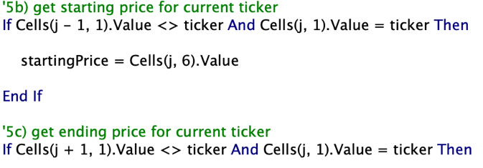The refactored code and the original solution code both have advantages and disadvantages to them. One advantage of the module solution code is that it is easier to understand compared to the edited code. By this I mean that the language used in the code is in a simpler format. This can be seen in the picture below. I feel that the way the code is written to get the starting price and ending price for the ticker is easier to understand compared to the refactored code. Though I touched on the advantage of the refactored code being quicker, there is another advantage to the refactored code. Another advantage of that code is initializing the arrays early on. This allowed me to use the arrays to condense the code, though more difficult to read for more basic and entry level coders, it made the code more efficient and quicker to run.